Zolatron: Memory & Addressing

|  |  |
| --- | --- |
| Last edited: | 14 Sep 2025 |

# Main sections

| Address Range | Used for |
| --- | --- |
| $0000 – $07FF | System variables, buffers etc. |
| $0800 – $7FFF | User RAM |
| $8000 – $9FFF | Extended ROM/RAM |
| $A000 – $BFFF | I/O |
| $C000 – $FFFF | System ROM |

# Lower 2K

Pages 0–7 ($0000–$07FF) are reserved for system use:

| Pg | Address Range | Used for | Defined in: |
| --- | --- | --- | --- |
| 0 | $0000–$00FF | Zero page variables | cfg_page_0.asm |
| 1 | $0100–$01FF | 6502 system stack | — |
| 2 | $0200–$02FF | OS indirection table | cfg_page_2.asm |
| 3 | $0300–$03FF | STDIN & STDOUT buffers and indices | cfg_main.asm |
| 4 | $0400–$04FF | Buffers etc – includes STR_BUF, variables for temporary values & maths operations | cfg_page_4.asm |
| 5 | $0500–$05FF | User program workspace | — |
| 6 | $0600–$06FF | ZolaDOS workspace | cfg_ZolaDOS.asm |
| 7 | $0700–$07FF | SPI workspace | cfg_page_7.asm |

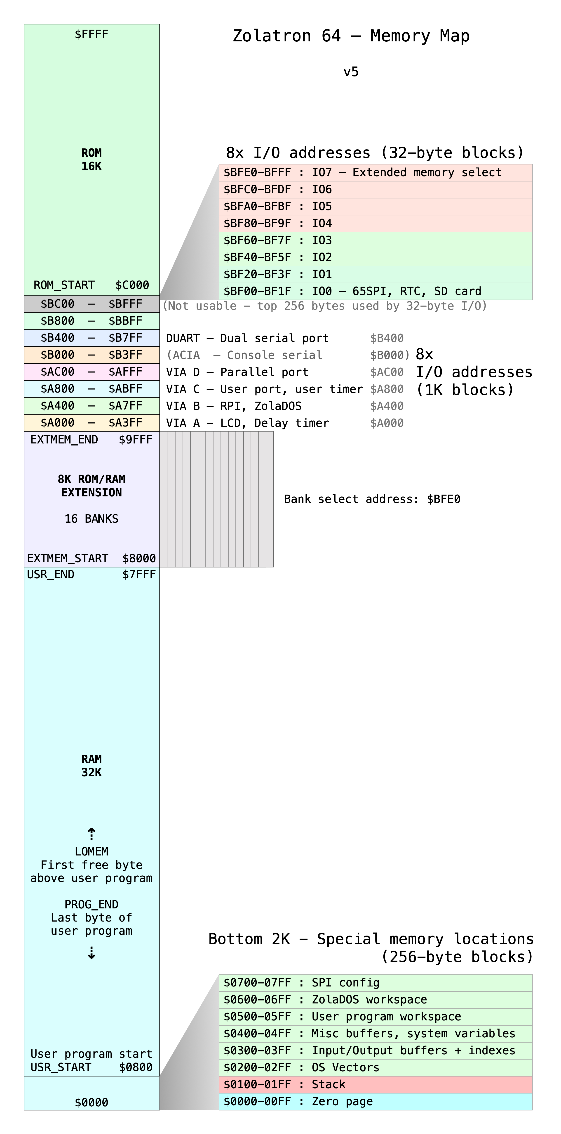

# ZERO PAGE

Defined in cfg_page_0.asm.

|  |  |  |
| --- | --- | --- |
| Address | Name | Description |
| $E0, $E1 | MSG_VEC | Pointer to a message (to print) |
| $E2, $E3 | FUNC_RES_L, FUNC_RES_H | To hold a 16-bit return value for a subroutine |
| $E4 | FUNC_RESULT | Holds a 1-byte return value for a subroutine |
| $E5 | FUNC_ERR | Stores an error code returned from a subroutine |
| $E6, $E7 | TBL_VEC_L, TBL_VEC_H | LSB and MSB of a location within a lookup table |
| $E8, $E9 | TMP_ADDR_A_L, TMP_ADDR_A_H | Temporary 16-bit address (TMP_ADDR_A is an alias for TMP_ADDR_A_L) |
| $EA, $EB | TMP_ADDR_B_L, TMP_ADDR_B_H | Temporary 16-bit address (TMP_ADDR_B is an alias for TMP_ADDR_B_L) |
| $EC, $ED | TMP_ADDR_C_L, TMP_ADDR_C_H | Temporary 16-bit address (TMP_ADDR_C is an alias for TMP_ADDR_C_L) |
| $EE, $EF | FILE_ADDR |  |
| $F0, $F1 | PROG_END | Address of last byte of user program |
| $F2, $F3 | LOMEM | First available byte after user prog |
| $F4 | STDIN_STATUS_REG | STDIN flags |
| $F5 | SYS_REG | System flags |
| $F6 | IRQ_REG | IRQ flags |
| $F7-$FB | – not used – | 5 bytes |
|  |  |  |
| $FC, $FD | USRINT_VEC | Indirect jump vector pointing to userland ISR |
| $FE, $FF | USRINTTRN_VEC | Indirect jump vector returning from userland ISR |

# PAGE 3 – $0300–$03FF

## I/O buffers, temp storage etc

Defined in cfg_main.asm.

|  |  |  |
| --- | --- | --- |
| $0300 – $037E | STDIN_BUF | 127 |
| $037F | STDIN_IDX | 1 |
| $0380 – $03FE | STDOUT_BUF | 127 |
| $03FF | STDOUT_IDX | 1 |